Ennio da Silva Vitor student number:

O p e r a t i n g S y s t e m s / C o n t i n u o u s A s s e s s m e n t 3

C l i e n t - S e r v e r V i r t u a l N e t w o r k

D e c e m b e r 2 0 1 6
Project

This project has the objective of set all the services needed to allow the motortax.cct to work with domain controller, DHCP, DNS and ISS services allow clients to have access to the contents of the web page: www.motortax.cct and ftp.motortax.cct.

Setup

The screenshot above shows the system information of the server set as domain control.
Computer name: DC2015197.
The domain address is: Domain5197.cct.
Computer description: Server.

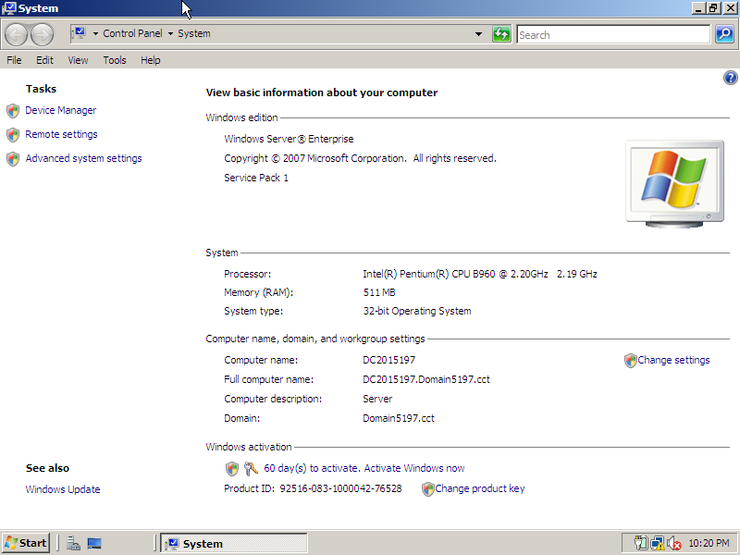

Server is configured with a static IP address of 192.168.1.50, subnet Mask: 255.255.255.0 and default gateway 192.168.1.1.

The Domain controller has the IP address set as 192.168.1.50

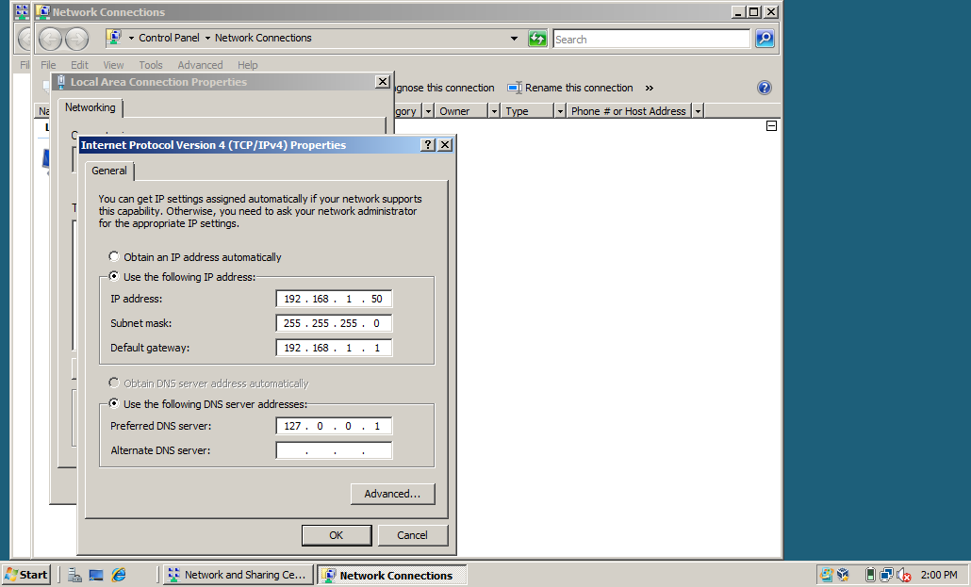

On this picture we can identify the server with the current configuration.
  - DHCP
  - DNS
  - IIS 6.0
  - and IIS

For this assignment those are the main services needed.

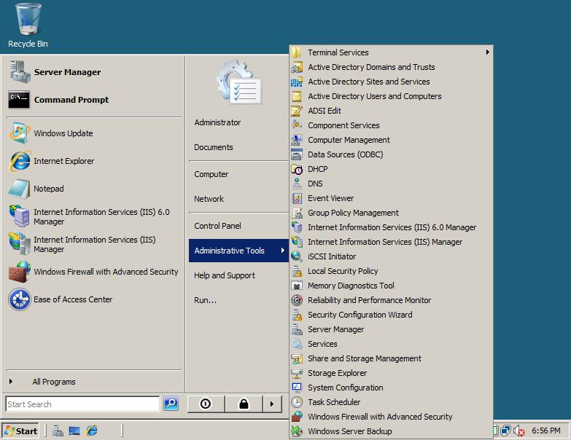

The client does not have any role for domain control.
Also this station is set with a administrator account. It means that this account has control of any command that the user may need to set, this client yet, does not set any command to the server, the relationship between this client and the server is: the client can view any information that the server may turn public (to the network). Example, Web sites or FTP files that contains relevant information to guide the users (clients) to complete tasks.

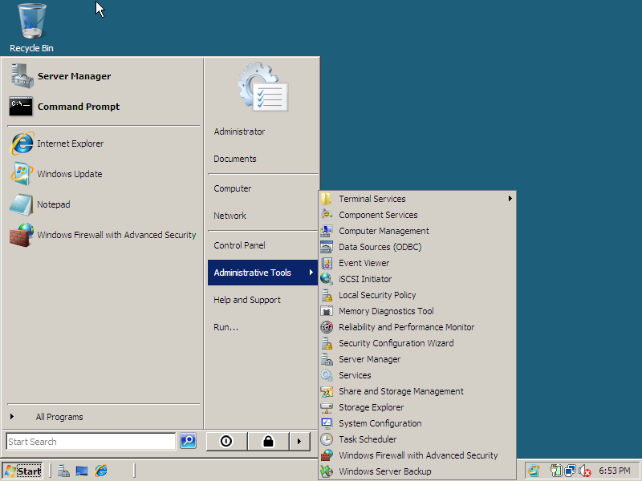

To make the connection between the client and server, the client must be connected with the domain of the server. To do this, the client must set the user name and password in the wizard window that pop up when the client type the name of the domain controller and press OK.

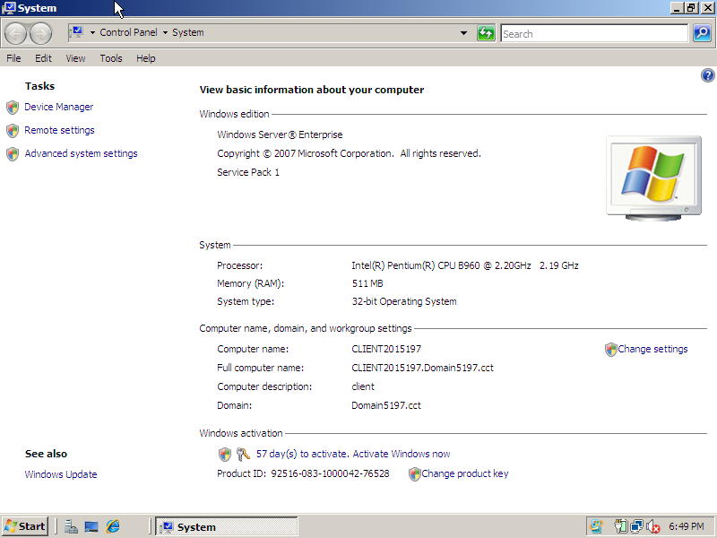

An other set that has to be done on the client side is the IP address of the DNS server that will be the same IP of the server computer.
The client is configured with, dynamic IP address.
And DNS server address of: 192.168.1.50.

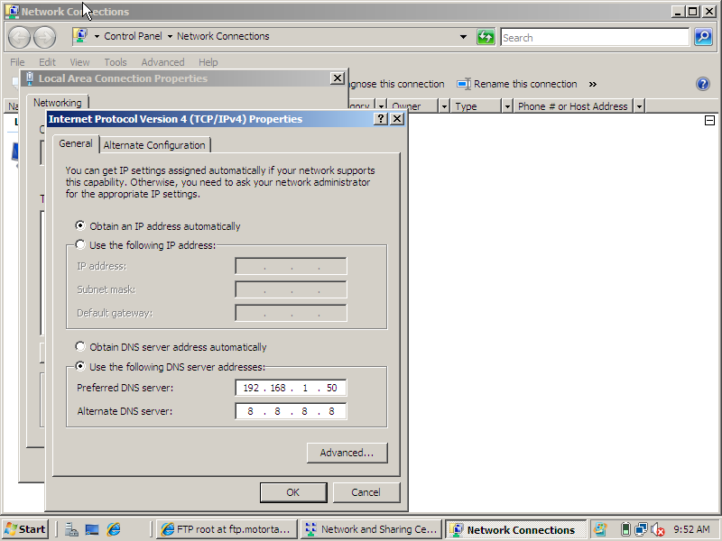

For the server: The roles we have are:
  - ADDS that allow the user to have access to the contents shared of the server. Once the user logon to the domain.
  - DHCP server: that will be explained later.
  - DNS server: That resolve the IP address where computer can identify, to a name resolution that humans can identify. The DNS server can resolve computer names or services into a network. If we set a world wide web folder or a file transfer protocol folder, with the DNS service we will allow clients to access those folders by type the address of given into the browser. Example: www.motortax.cct or ftp.motortax.cct both are valid address and the www one will bring the web site of the service and the ftp. Will show the links of files that are usable to the client.
  - Web server (IIS): Can be used by www. Web Sites or ftp. Web sites and Is responsible for let the clients to download or upload contents from a server that runs IIS role. It is very useful service, because with this role the clients have an easy access to contents. Example: software, forms, applications, documents or other contents that could be delivered physically by cd, dvd, memory stick or papers.
To this CA, the forms from the ftp.motortax.cct are available to down load.

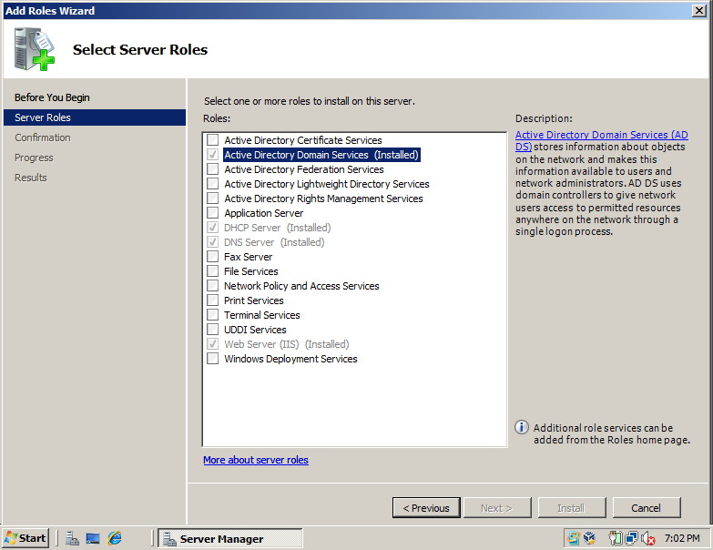

The server is managing the range of IP address by the DHCP. And the addresses are 192.168.1.1 to 192.168.1.200.

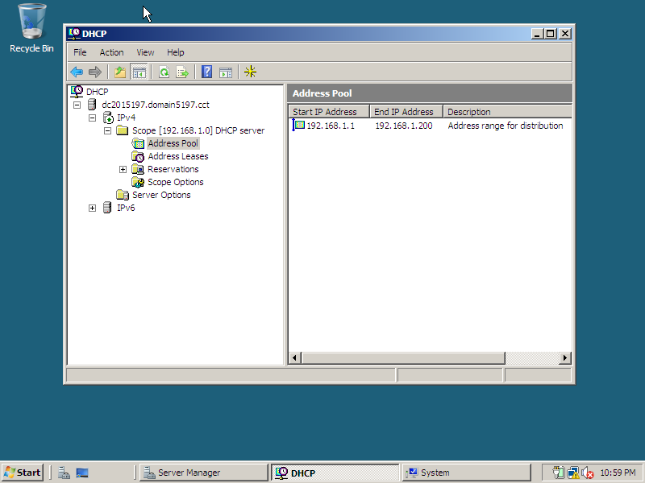

To the reserved address, the Client2015197 will have the address 192.168.1.70. this client have a dynamic IP address but because this IP is reserved every time that this client connect to the domain the DHCP will give the 192.168.1.70 address.

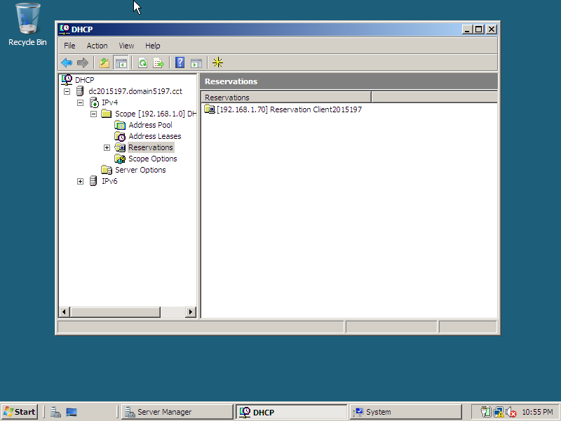

Basically the range 192.168.1.1 to 192.168.1.50 is excluded from distribution, it means that any client that connect to the domain will not receive those address because the network is reserving it for private connections.

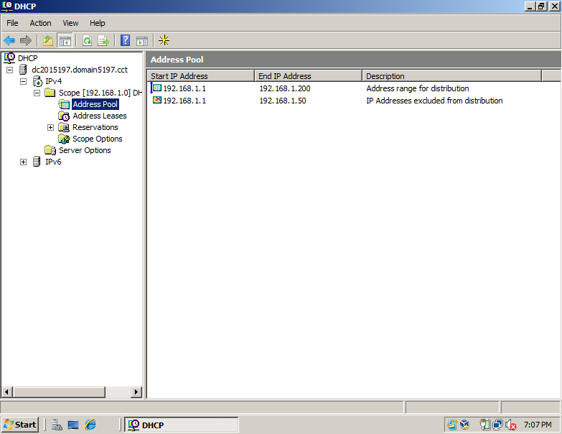

The DNS manage is setting the www. And ftp. For the MotorTax.CCT.

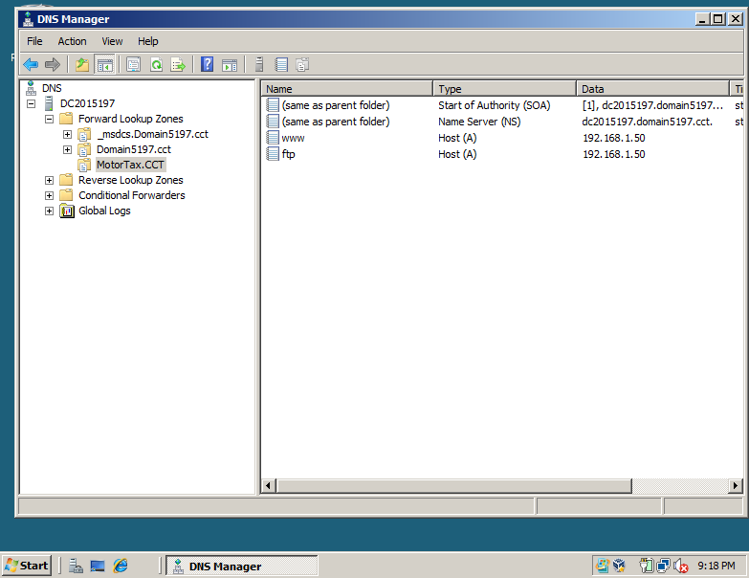

The IIS service is set to the FTP folder of motortax and will allow clients to download the contents of the folder.

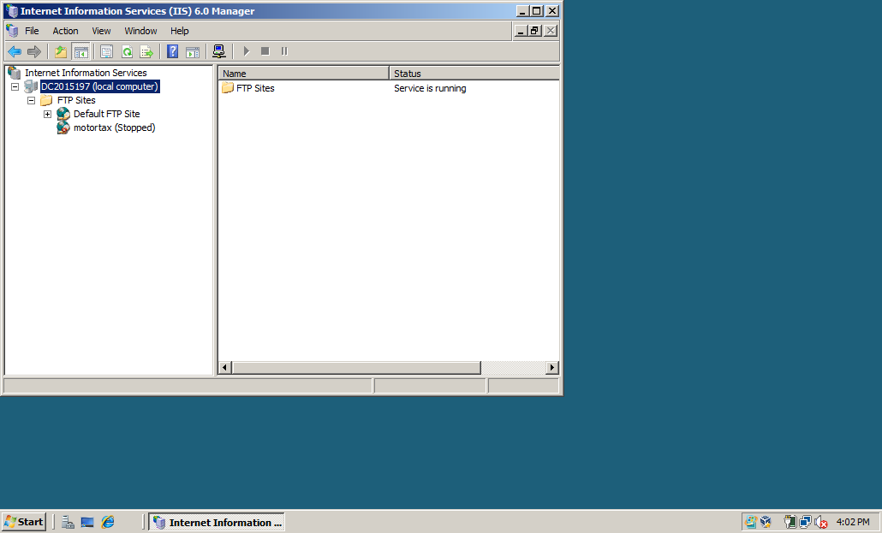

This screen shot shows that the client is well reconfigured and is communicating with the server, also the connections is good because by test it with a ping to the 192.168.1.50(server) all the packs have been sent and received.

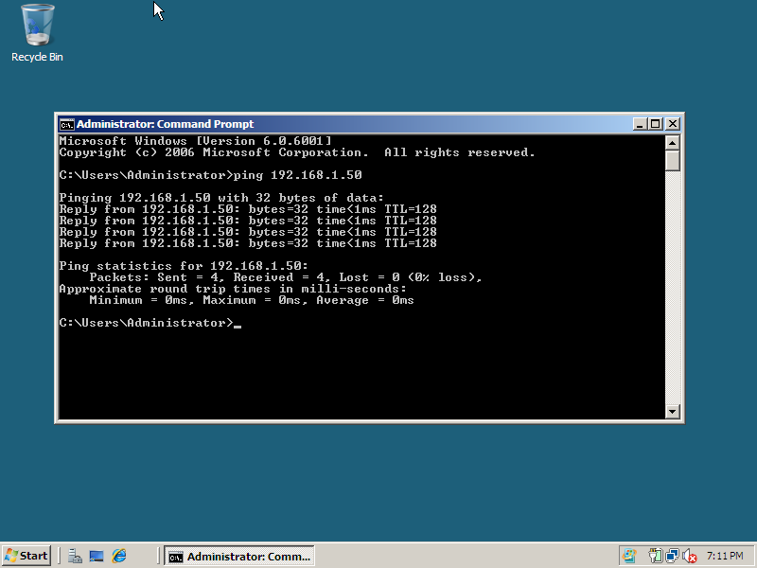

From the server side: The connection is good the ping command to the client sent and received all packets.

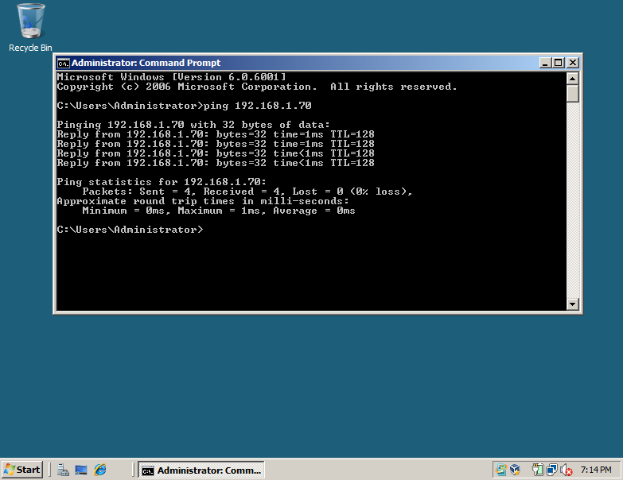

The client is dynamic and is getting the reserved IP address of the DHCP from the server.

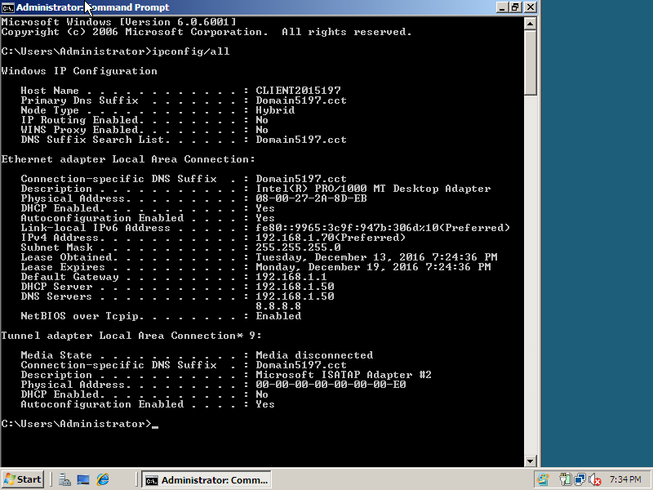

The screen shot above is a test from the client side as shown in the command prompt the IP 192.168.1.70. And the www.motortax.cct/ is working as expected.

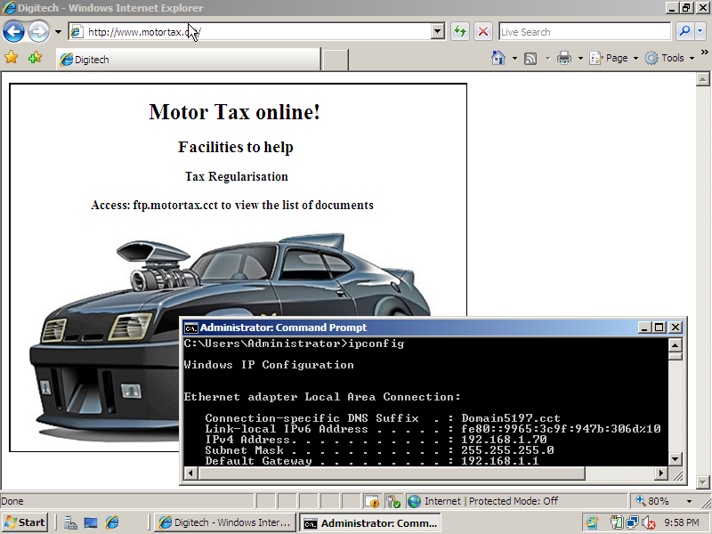

The client 192.168.1.70 is also can view the ftp.motortax.cct/ and the client now can download the contents.

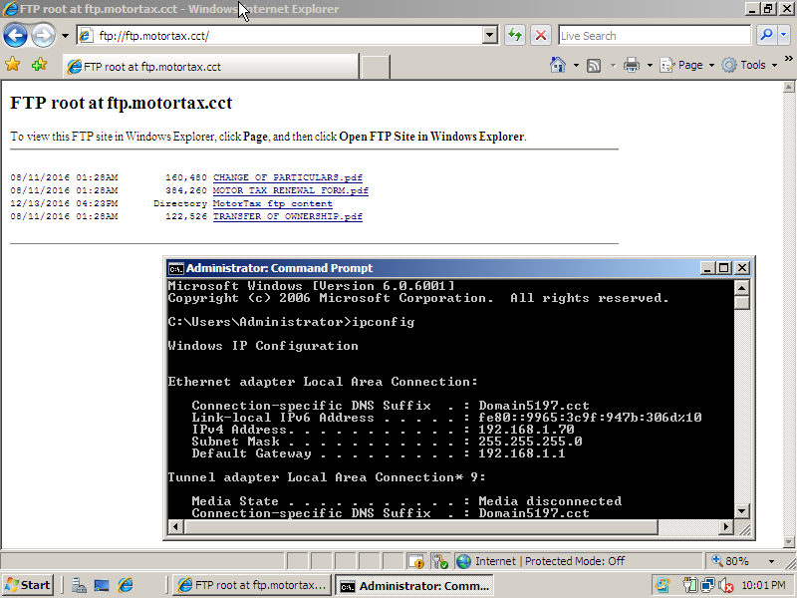

References

Microsoft (2016). Web Server (IIS) Role Overview. Available at: https://technet.microsoft.com/
en-us/library/cc770634(v=ws.11).aspx. [Accessed on 19th December 2016]

Microsoft (2016). DNS Server Overview. Available at: https://technet.microsoft.com/library/cc7
70392.aspx. [Accessed on 19th December 2016]

Pinterest (2016) Mad Max Interceptor Muscle Car [image online], available: https://www.Pinter
est.com/pin/420312577695498321/ [accessed 19 December 2016].

I hereby declare that all of the work shown here is my own work

Ennio da Silva Vitor

Student number: 2015197

